BNO055 IMU
INTEGRATION GUIDE
Wiring, driver setup, calibration, and troubleshooting for the Bosch BNO055 IMU
ROS 2 Humble • NVIDIA Jetson Orin Nano
Version 1.0
Date: July 2026

Table of Contents
1. Overview
2. System Requirements
3. Hardware Connections
4. System Architecture
5. Package Setup
6. Modifying the I2C Driver
7. Configuring the Driver
8. Building the Package
9. Running and Verifying the Node
10. Calibrating the IMU
11. Saving Calibration Offsets
12. Troubleshooting
13. Verification Checklist
14. Summary

1. Overview
This document provides a complete guide for integrating the Bosch BNO055 IMU with ROS 2 Humble on the NVIDIA Jetson Orin Nano Developer Kit. It covers:
- Package setup
- Workspace configuration
- Dependency installation
- Building the ROS 2 package
- Resolving common I2C communication issues
- Verifying sensor communication
- Calibrating the IMU
- Saving calibration offsets
- Troubleshooting

2. System Requirements

Hardware
- NVIDIA Jetson Orin Nano Developer Kit
- Bosch BNO055 IMU module
- Jumper wires
- 40-pin GPIO header

Software
- Ubuntu 22.04
- ROS 2 Humble
- Python 3.10
- Colcon
- Git

3. Hardware Connections
Connect the BNO055 as follows:
Jetson Pin | Signal | BNO055 Pin
Pin 1 | 3.3V | VIN
Pin 6 | GND | GND
Pin 27 | SDA | SDA
Pin 28 | SCL | SCL

Note: ensure the IMU is configured for I2C mode.

4. System Architecture
The diagrams below show the physical wiring and the resulting ROS 2 data flow.
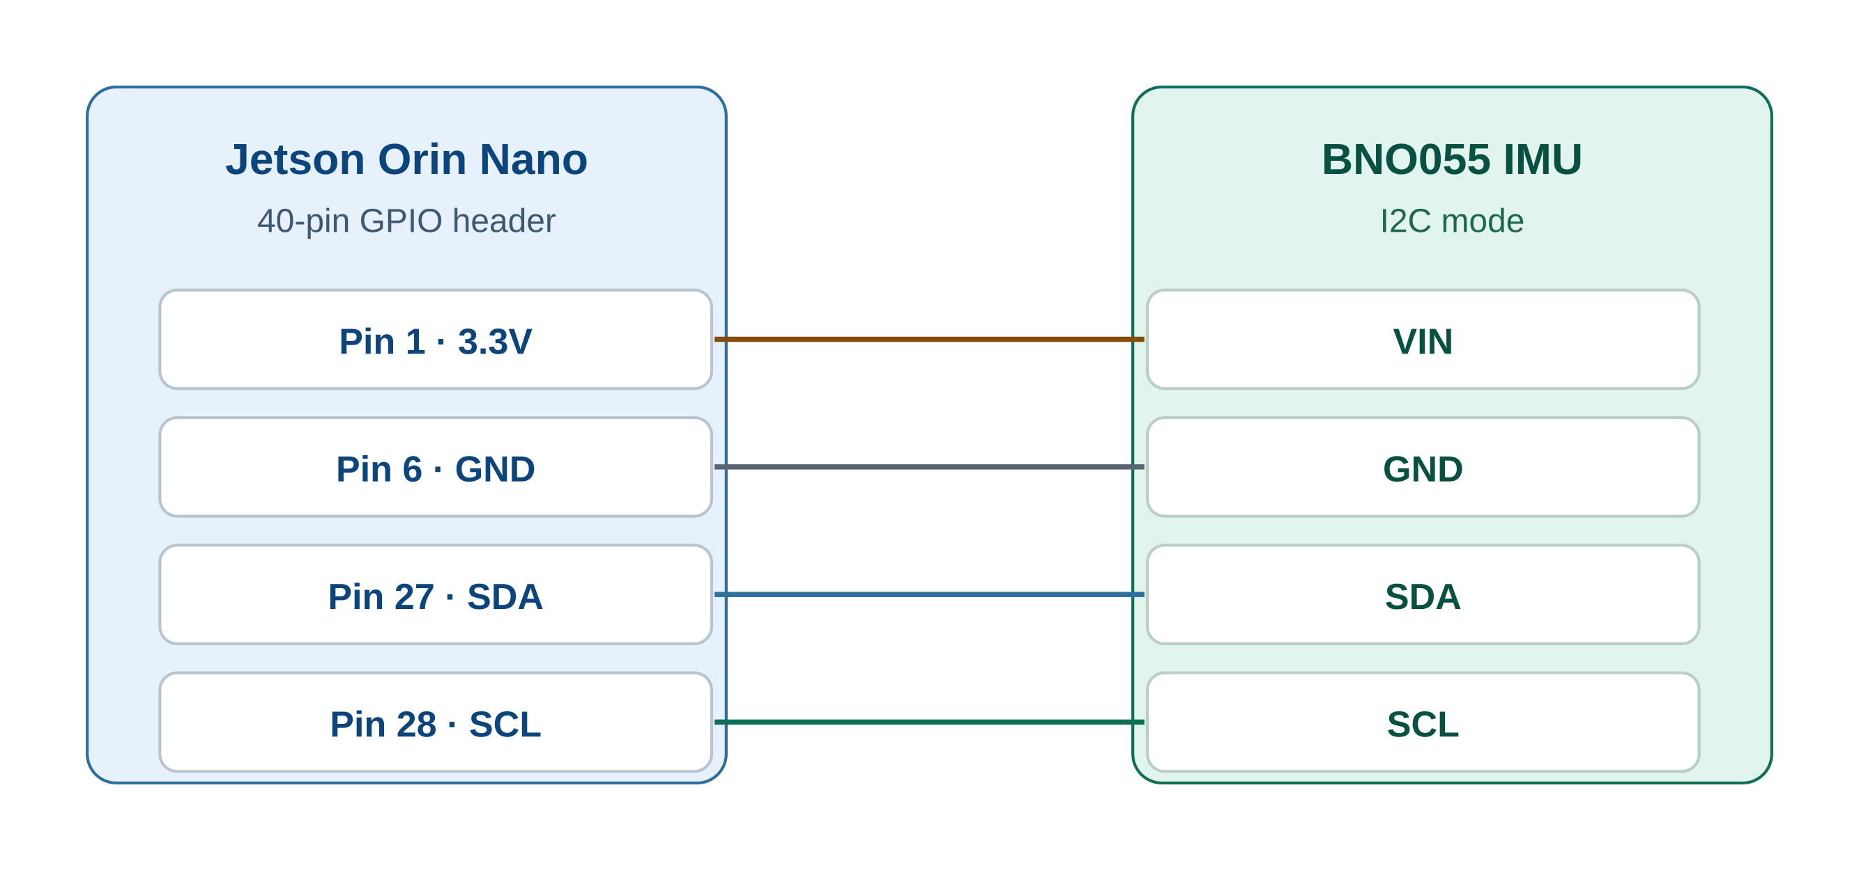
Figure 1 — Hardware wiring between the Jetson Orin Nano and the BNO055
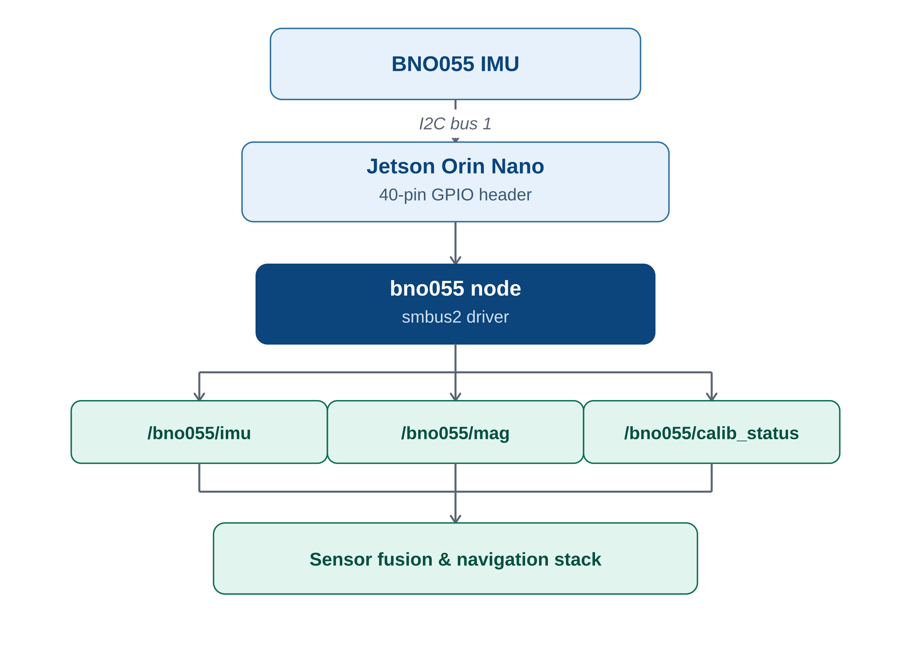
Figure 2 — BNO055 ROS 2 data flow

5. Package Setup

Clone the Package
Navigate to the ROS 2 workspace source directory and clone the repository.
cd ~/ros2_ws/src
git clone https://github.com/flynneva/bno055.git

Install Dependencies
Update the system and install the required I2C tools and Python libraries.
sudo apt update
sudo apt install i2c-tools
sudo apt install python3-smbus
pip3 install smbus2

6. Configuring the Driver
Open bno055/params/bno055_params_i2c.yaml and update:
i2c_bus: 1
Leave i2c_addr: 0x28 unchanged, and initially use:
set_offsets: false

7. Building the Package
The diagram below summarizes the complete sequence from cloning the package to running the node.
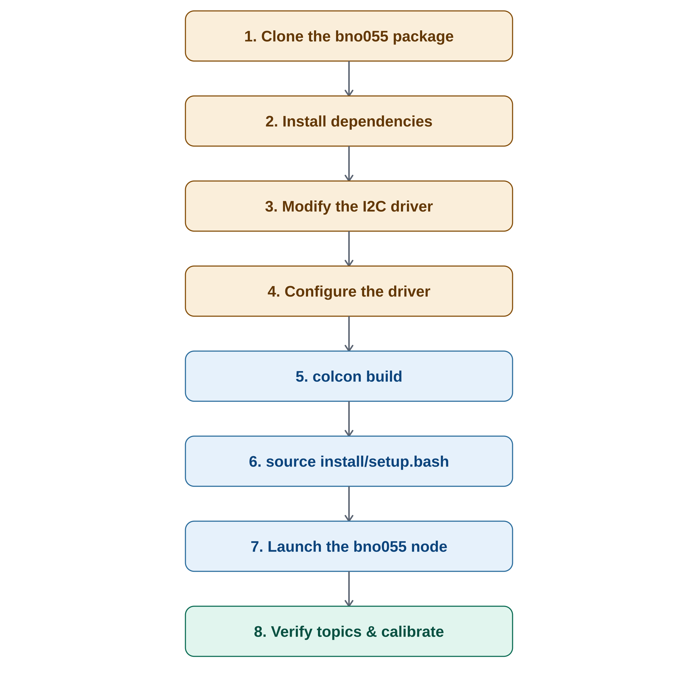
Figure 3 — Package setup and build workflow
Navigate to the workspace, build, and source it.
cd ~/ros2_ws
colcon build --symlink-install --packages-select bno055
source install/setup.bash

8. Running and Verifying the Node
After successfully building the package and sourcing the workspace, the BNO055 node can be started using any of the following methods, depending on the application.

Method 1 — Run with Default Parameters
This method launches the BNO055 node using the default parameters installed with the package.
source ~/ros2_ws/install/setup.bash
ros2 run bno055 bno055

Method 2 — Run with a Custom Parameter File
Useful when testing different sensor configurations or modifying driver parameters without changing the default configuration.
source ~/ros2_ws/install/setup.bash
ros2 run bno055 bno055 \
--ros-args \
--params-file ~/ros2_ws/src/bno055/bno055/params/bno055_params_i2c.yaml
Typical parameters configured in the YAML file include:
- I2C bus number
- I2C device address
- Data publishing frequency
- Frame ID
- Sensor operation mode
- Calibration offsets
- Axis remapping
- Sensor covariance values

Method 3 — Launch File (Recommended)
The recommended approach is to use the launch file provided with the package. It automatically loads the configured parameter file and starts the BNO055 node with the required settings.
source ~/ros2_ws/install/setup.bash
ros2 launch bno055 bno055.launch.py
This method is recommended because it:
- Automatically loads the configured parameter file.
- Simplifies node startup with a single command.
- Is easier to integrate into larger robotic applications.
- Provides a consistent launch configuration across systems.
On successful startup, the terminal should display:
Detected BNO055 Chip ID: 0xA0
Successfully connected to BNO055.

Verifying Successful Execution
Check active ROS 2 nodes:
ros2 node list
Expected output:
/bno055
List published topics:
ros2 topic list
Example topics:
/bno055/imu
/bno055/mag
/bno055/calib_status
View IMU data and calibration status:
ros2 topic echo /bno055/imu
ros2 topic echo /bno055/calib_status

Verifying I2C Communication
List available buses and scan bus 1.
i2cdetect -l
sudo i2cdetect -r -y 1
Expected output: 28 where 0x28 is the BNO055 address.
Read the chip ID and the operating mode register.
i2cget -y 1 0x28 0x00
i2cget -y 1 0x28 0x3D
Expected chip ID: 0xA0.

9. Calibrating the IMU
The BNO055 reports calibration values from 0 to 3.
Value | Meaning
0 | Not calibrated
1 | Low calibration
2 | Partial calibration
3 | Fully calibrated

Goal: System = 3, Gyro = 3, Accel = 3, Mag = 3.

Gyroscope Calibration
Keep the sensor completely stationary for approximately 10-20 seconds.
Target: Gyro = 3.

Accelerometer Calibration
Rotate the IMU slowly and place it in multiple orientations, for example:
- Flat
- Upside down
- Left side
- Right side
- Front
- Back
Target: Accel = 3.

Magnetometer Calibration
Move the IMU slowly in a large figure-eight motion while rotating it around all three axes. Avoid performing calibration near:
- Magnets
- Large metal objects
- Electric motors
- High-current cables
Target: Mag = 3.

System Calibration
After all individual sensors are calibrated, the system calibration should also reach the fully calibrated state shown below.
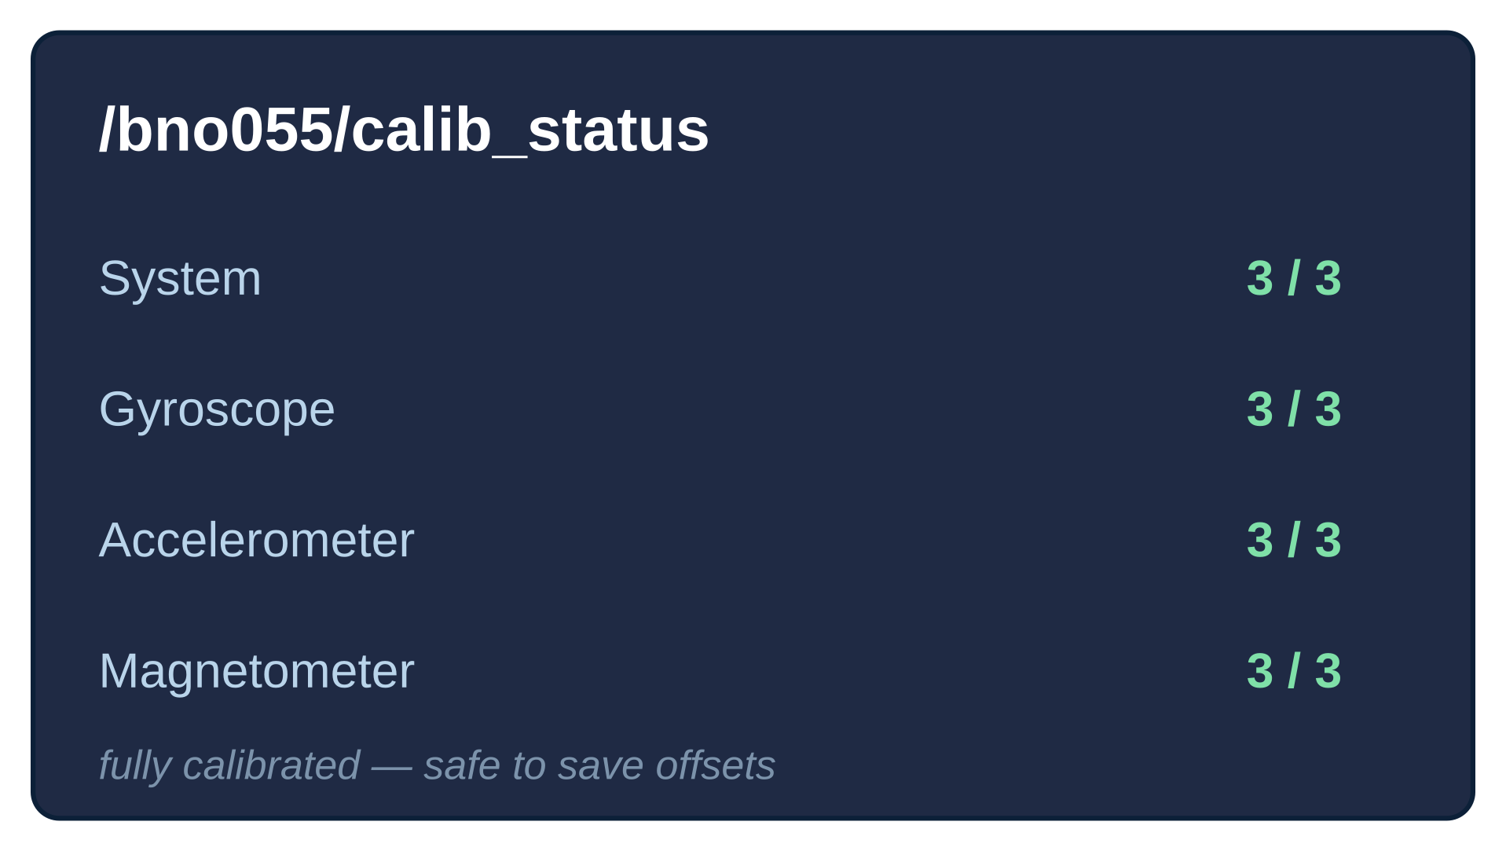
Figure 4 — Fully calibrated /bno055/calib_status output

10. Saving Calibration Offsets
Calibration offsets are unique to each BNO055 sensor. After achieving full calibration (System = 3, Gyro = 3, Accel = 3, Mag = 3), read the sensor offsets and update:
offset_acc:
offset_mag:
offset_gyr:
radius_acc:
radius_mag:
Then change:
set_offsets: true
Rebuild the package.
colcon build --symlink-install --packages-select bno055
source install/setup.bash
On subsequent launches the driver automatically loads the saved offsets.

12. Troubleshooting

ModuleNotFoundError: No module named smbus
Install one of the following:
sudo apt install python3-smbus
# or
pip3 install smbus2

Remote I/O Error (Errno 121)
Possible causes:
- Incorrect I2C bus
- Incorrect wiring
- Wrong sensor address
- Using the legacy smbus library
Verify:
i2cget -y 1 0x28 0x00
Expected: 0xa0.

BNO055 Not Detected
sudo i2cdetect -r -y 1
Expected: 28. If no address appears:
- Check power
- Check SDA/SCL connections
- Verify bus number
- Verify sensor mode

13. Verification Checklist
✓ Sensor detected using i2cdetect.
✓ Chip ID returns 0xA0.
✓ Driver launches successfully.
✓ /bno055/imu publishes data.
✓ /bno055/calib_status publishes calibration status.
✓ Calibration reaches System = 3, Gyro = 3, Accel = 3, Mag = 3.
✓ Calibration offsets saved (set_offsets: true).
✓ Driver loads calibration automatically after reboot.

14. Summary
Following this procedure ensures a reliable integration of the Bosch BNO055 IMU with ROS 2 on the Jetson Orin Nano. The guide covers installation, configuration, verification, calibration, and troubleshooting, enabling both beginners and experienced ROS users to deploy the sensor successfully.

